Waves

__________ -a traveling disturbance that transmits __________ without transferring __________.
Types of waves:
- ________________
  - Examples -- light waves, radio waves, microwaves, X-rays, etc.
  - Do _____ require a _________ for transfer; can be transferred through a vacuum
  - 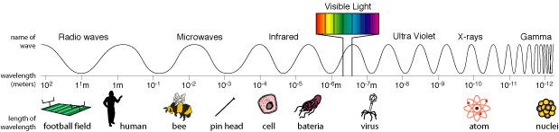
- _______________
  - Examples -- sound waves, water waves, etc.
  - __________ medium for transfer; __________ be transferred through a vacuum
  - The __________ of the wave depends upon the __________.
  - Some waves are __________ (particles undergo back and forth displacement as in a sound wave.)
  - Some waves are__________ (particles undergo up and down displacement as in a wave on a string.)

Types of mechanical waves:
- __________ -
As a wave passes through a point, the particles vibrate at right angles to the direction in which the wave is moving

__________ upward displacement of transverse wave
__________ downward displacement of transverse wave
Speed of a transverse waveThe speed of a transverse wave depends upon the __________ or force the medium is subjected to.
2. __________-
As wave passes through a point, the particles vibrate __________ to the direction in which the wave is moving
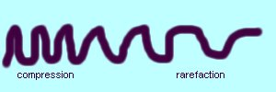
• Speed of a longitudinal wave The speed of a longitudinal wave depends upon the properties of the __________.
Wave terms:
- __________ -
the distance between two successive in-phase points; symbol is λ and SI unit is meters
- __________ -
maximum displacement of wave; measure of wave's energy
__________ -single disturbance of a medium
__________ -the number of waves passing a point per second; symbol is f and SI unit is Hertz (Hz)
- __________ - time for one wave; symbol is T and SI unit is second
T = 1/f
f = 1/T
- __________ -
the speed with which the wave moves through the medium is the product of the wavelength and the frequency; SI unit is m/s
v = λ f
Wave properties
- __________-
"bouncing back" of a wave
  - __________ -- The angle of incidence __________ the angle of reflection (or it can be stated θ₁ = θ₂)
  - Angle of incidence and angle of reflection are __________ drawn relative to the __________.

__________ - line drawn perpendicular to surface
  - Example of reflection - echo
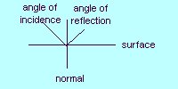

- __________ - "bending of waves"
  - A wave passing from one medium to another medium of different __________ changes its __________ causing it to ______
  - The speed of the wave is greatest in the less dense medium
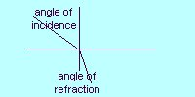

*A wave that moves from a low density medium to a high density medium
...... Transmits unchanged THEN is reflected inverted

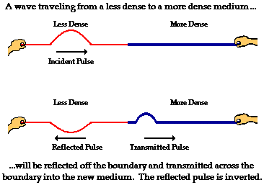

A wave that moves from a high density to low density medium.....
Transmits unchanged THEN reflects unchanged

- __________ - result of the superposition of two or more waves
  - __________ __________ - when two waves are in the same place at the same time

__________ __________ -waves interfere, "adding" to produce a larger wave


__________ __________ -waves interfere, "adding" to produce a smaller wave
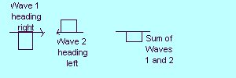

__________ __________ -two waves with the same wavelength, the same frequency, and the same amplitude that are traveling through a medium in opposite directions interfere producing a standing wave

Draw a diagram of:
fundamental-
1st harmonic
2nd harmonic
3rd harmonic
__________ -point of zero displacement on a standing wave
__________ -
point of maximum displacement on a standing wave

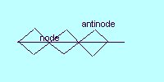
- __________ -
spreading of waves around a barrier

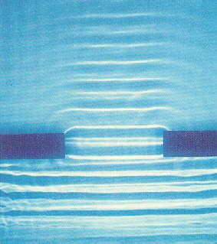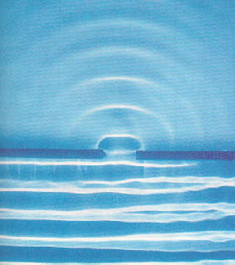

Waves at boundaries between different media:
- speed of wave doesn't depend upon frequency or amplitude of wave; speed depends upon the properties of the __________
- at a boundary, part of the incident wave is __________ back upon itself in the original medium and part is __________ through the second medium
- the _____ ______ the second medium is, the less wave ________ is transmitted

- the reflected wave, the incident wave, and the transmitted wave all have the same frequency; the velocity and the wavelength of the waves change
- when a wave passes from a ______ _____to a more dense medium, the reflected wave is _________
- when a wave passes from a more dense to a less medium, the reflected wave is _____________

